Week in Review - April 5-12
Alex Shvartsman
It has been a very slow week, with no title tournaments played across the globe, nor any major announcements. Most players are busy preparing for their respective Regional and National championships.

ROOKIE OF THE YEAR RACE

Although I try to talk about the developments in the Player of the Year race every other week or so, I have not talked about the Rookie of the Year race much - perhaps because it is relatively low-key, compared to last season. Last year, rookies became Pro Tour finalists in Chicago and London - starting off their PT efforts with 24 points each. After a close race throughout the rest of the season, Brian Davis earned the title over Thomas Preyer thanks to his ninth place finish at the World Championships in Brussels.
This year, the ROY race leader's top achievement is Top 8 at Pro Tour-LA. Lawrence Creech, a player from Virginia has a solid lead at 23 Pro Tour points. He backed up his finish in LA with Top 32 at Pro Tour Chicago and a 33rd place finish in Tokyo. If Creech manages to continue his streak of such strong finishes, he might earn the title virtually unopposed.
In the second place at 17 points is Katsuhiro Mori. Mori is a young Japanese player who earned most of his points by placing in Top 8's of three consecutive Grand Prix. He traveled to the Pro Tour for the first time in LA, where he made Day 2, but failed to earn money or extra PT points at 81st place. In Tokyo, Mori did better, finishing 63rd. Mori could potentially challenge Creech, but it is unclear whether he will be able to travel to all the foreign Pro Tours.
With two Pro Tours left this season, any rookie can jump into the race by winning or making finals of a Pro Tour. My prediction however is that Creech will pull this one out, earning the Rookie of the Year title.
Rookie of the Year Standings can be found here.

MAGICAL WEDDING
Congratulations and best wishes to Bob Maher Jr. and his wife Courtney. The two were married this weekend in Madison, WI. Many Magic players attended. Gary Wise, who was there, will write about it in more detail in his column, Wise Words, next week.

YOUR MANA'S WORTH - Disenchanting a Hesitation
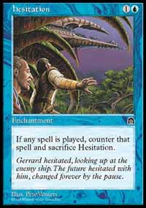
Two weeks ago, Matt Vienneau and I presented the readers of this column with a trivia question, asking about enchantments that could never be Disenchanted. The answer Matt had in mind was Hesitation - since any attempt to Disenchant it would have Hesitation sacrifice itself in an attempt to counter the Disnechant. Little did we know.
A number of players e-mailed me with creative solutions and situations where Disenchant actually could successfully counter a Hesitation. Here is an example of how to do this, provided by Joost Winter, a pro player from The Netherlands:
"To succesfully Disenchant Hesitation, you just have to do the following:
1. Cast Disenchant, targeting something.
2. When Disenchant is on the stack, cast Misdirection/Deflection, targeting the Disenchant (you only have to name the new target for Disenchant when the Misdirection resolves)
3. When Disenchant and Misdirection are on the stack, put Hesitation into play at instant speed (there must be several possibilities to do so, one of them is first playing Parallax Wave, Opalescence and Hesitation, waving Hesitation out, and, when the Disenchant and the Misdirection are on the stack, destroying the Parallax Wave).
When the stack resolves the following happens:
1. Hesitation is put back into play.
2. Misdirection resolves, and you choose Hesitation as the new target for Disenchant.
3.Disenchant resolves, destroying Hesitation."
Step 3 might be made simpler by sacrificing an Academy Rector to go get Hesitation in response to Misdirection being cast. Just thought I'd share this unorthodox solution with you guys.

MAGIC TRIVIA
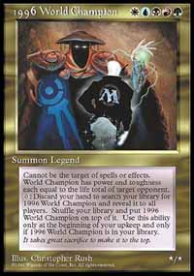
Last Week's Question:
What was the first Magic card to feature all five colors of mana in its casting cost?
Although many players might assume the answer is Sliver Queen, another card was actually made to feature a five-color casting cost. This unique card is the "1996 World Champion" and it was given as part of the prize to Ausrtalian Tom Champheng when he beat Mark Justice in the famous final match. The card's casting cost is , making it the first five-color card. This card is not legal for tournament play. Rumor has it, Champheng was offered as much as $10,000 for it, but understandably refused to sell.
New Question:
(Courtesy of Noah Weil)
What four red (non-gold) cards are capable of destroying Circle of Protection: Red with no help from any other cards?
Please do not e-mail me your answers. The correct answer will be posted in next week's column.

BEST OF THE NET
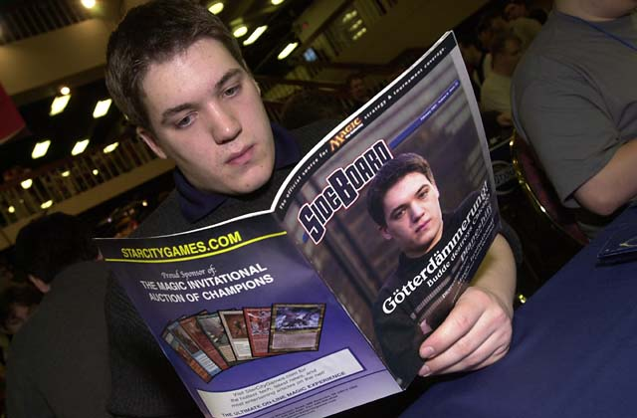
Where does he get his tech?
With Regionals around the corner, every bit of advice helps. If your plan is to play Rebels, check out a recent article by Kai Budde. It offers several builds, explanation of some of the key card choices, and even advice on how to sideboard in specific matchups.

PLAY OF THE WEEK
Brian David Marshall was playing a U-W deck in a booster draft tournament. His opponent stalled on three lands, while BDM kept on applying the pressure with Aurora Griffin and Tower Drake, and another blue creature. While his opponent was suffering from lack of mana, Brian himself was drawing plenty.
Brian drew his next card, smiled, and started tapping his Plains - turning his opponent's lands white via Griffin's ability! Confusion was quickly replaced by despair for his opponent, as BDM cast Wash Out naming white, setting his opponent back three more turns!

BAD PLAY OF THE WEEK
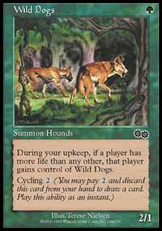
Variations of this play have been submitted at least a dozen times since I began writing this column, so I will finally write about it, to make everyone stop.
Apparently, quite a few players are fond of opening with City of Brass or Karplusan Forest, then tapping one of those lands to cast Wild Dogs or Ghazban Ogre. The result of course, is that a very happy opponent gains control of a green creature on their upkeep. I personally saw a player make this mistake TWICE in the same match. Slow learning curve, perhaps.
As always, please send good/bad plays, cool trivia questions, and other news to ashv@concentric.net.

